Page 1 — Create the EBS Volume
Topic: Amazon EBS volume creation
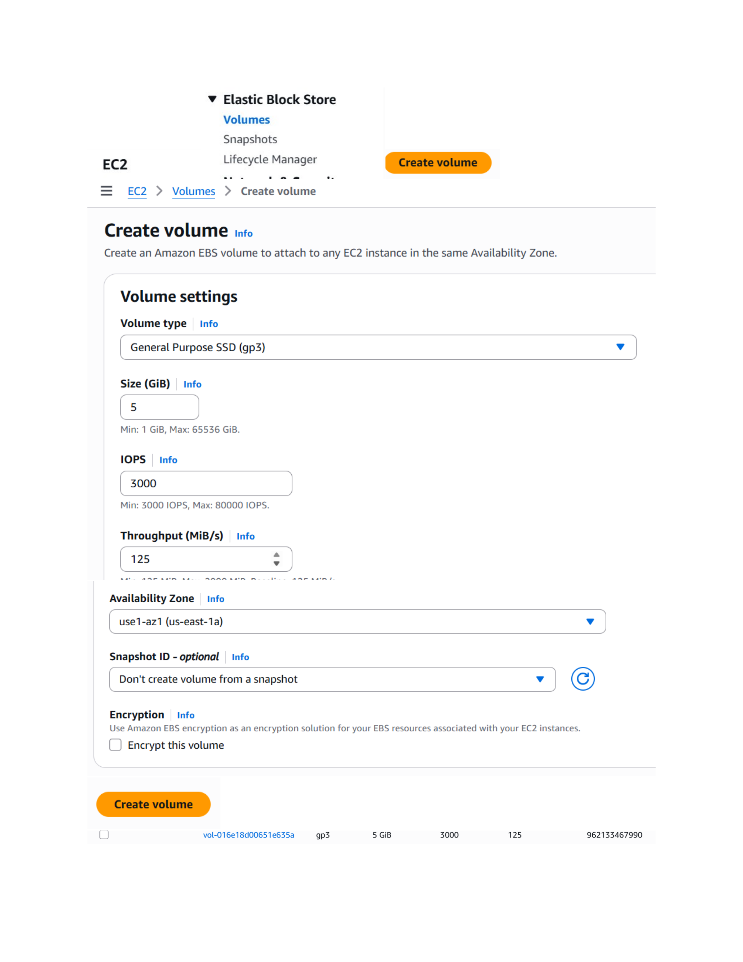
Actual action: A 5 GiB General Purpose SSD (gp3) EBS volume is configured in the selected Availability Zone with the shown IOPS and throughput settings, ready to be created.

Page 2 — Review the VPC Resources
Topic: VPC, subnet and Internet Gateway verification
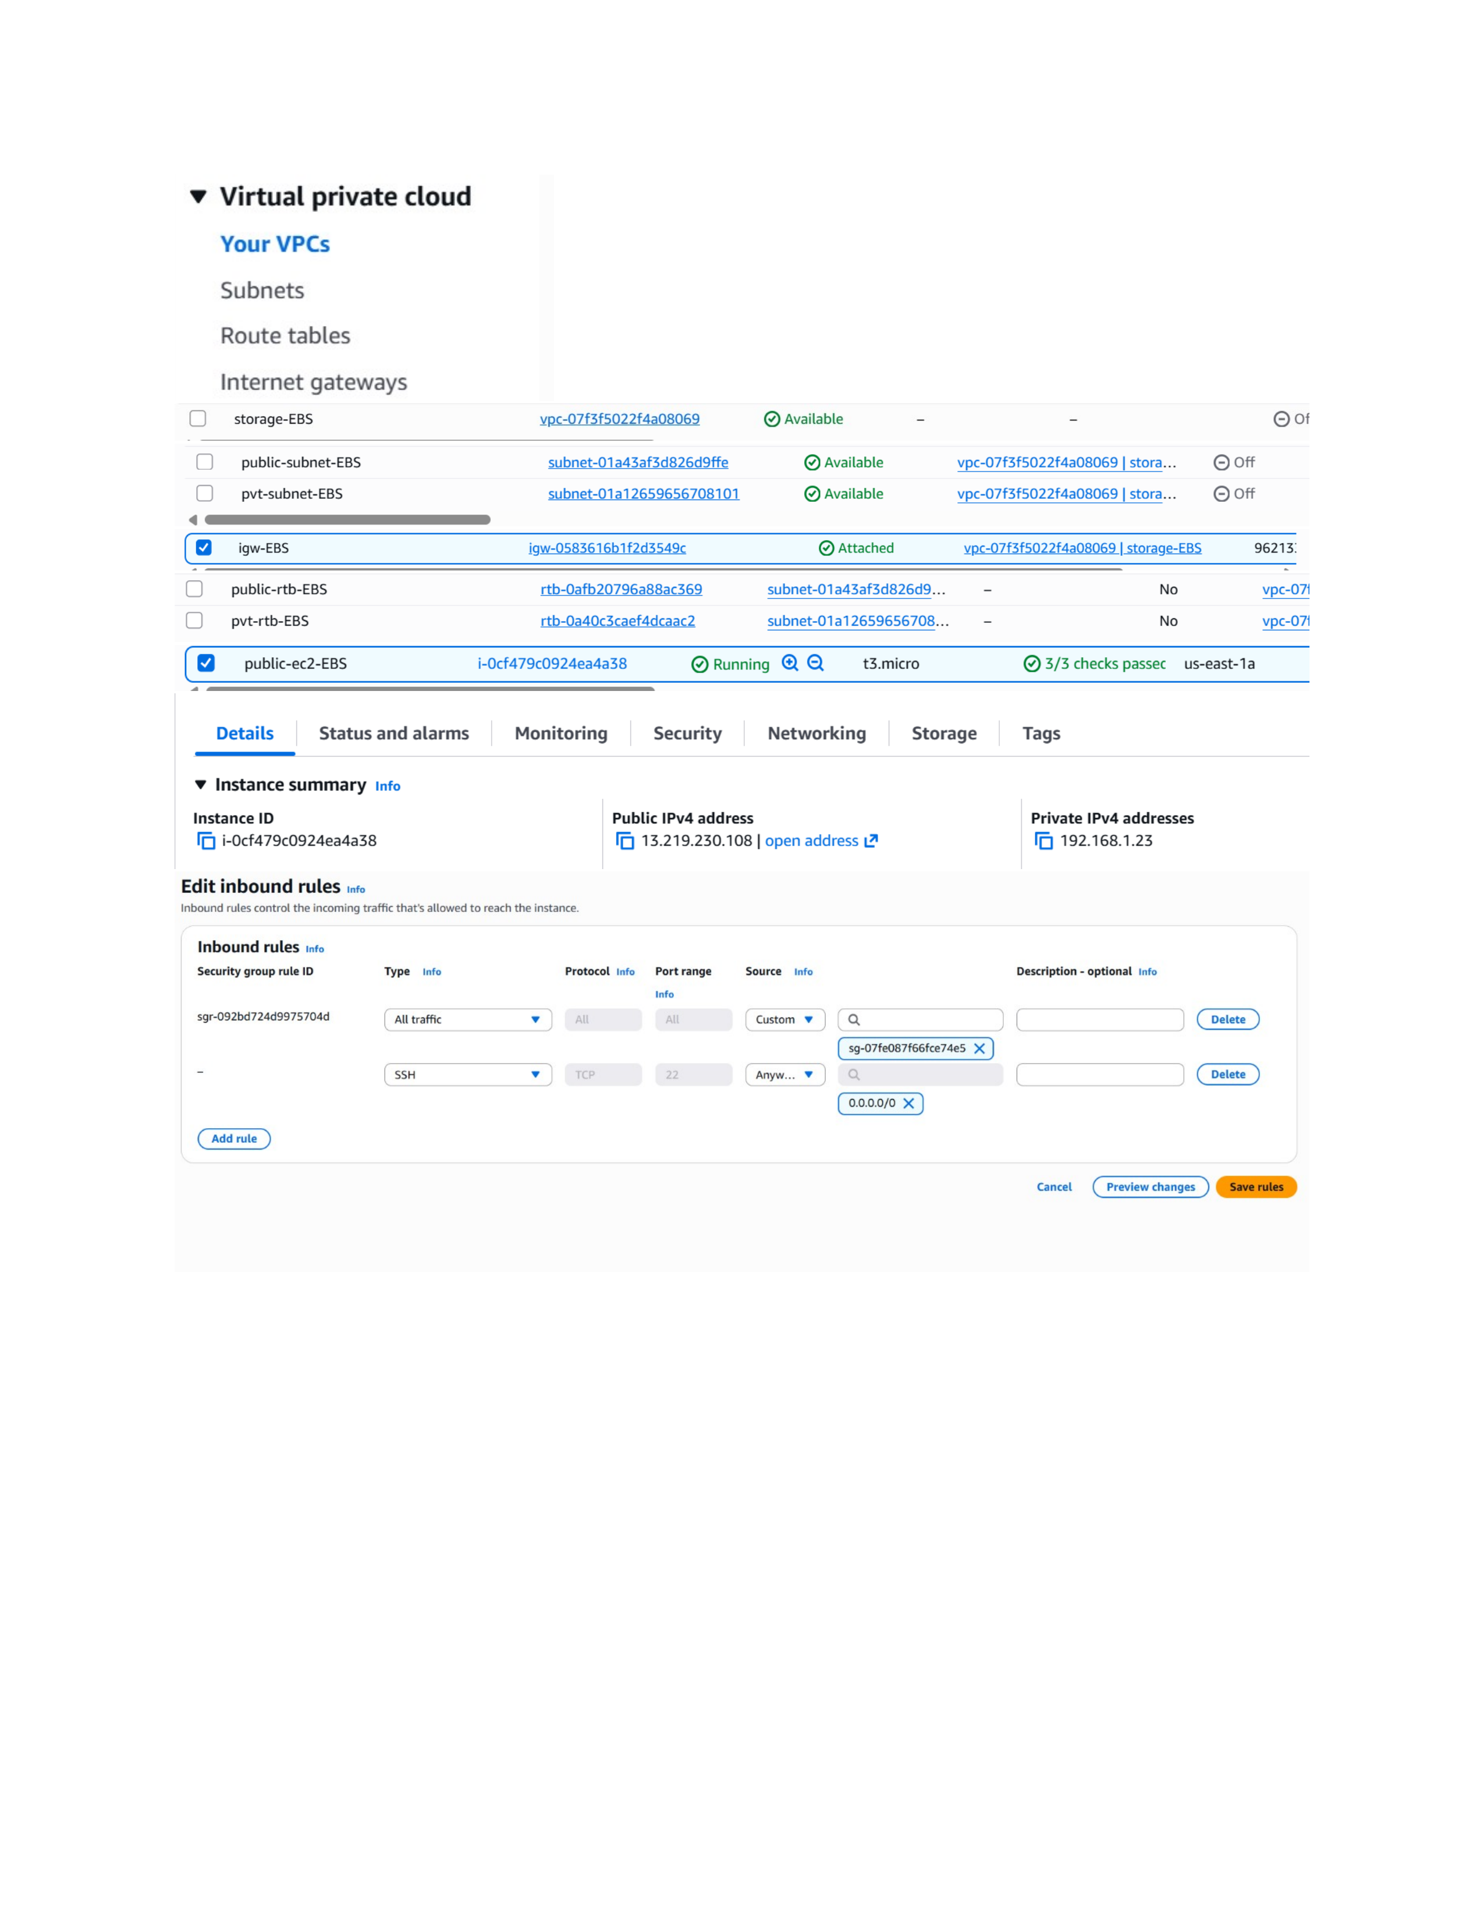
Actual action: The VPC console lists the EBS VPC, its public and private subnets, and the Internet Gateway, confirming the network resources used by the setup.

Page 3 — Connect to the EC2 Instance
Topic: SSH connection to the EC2 instance
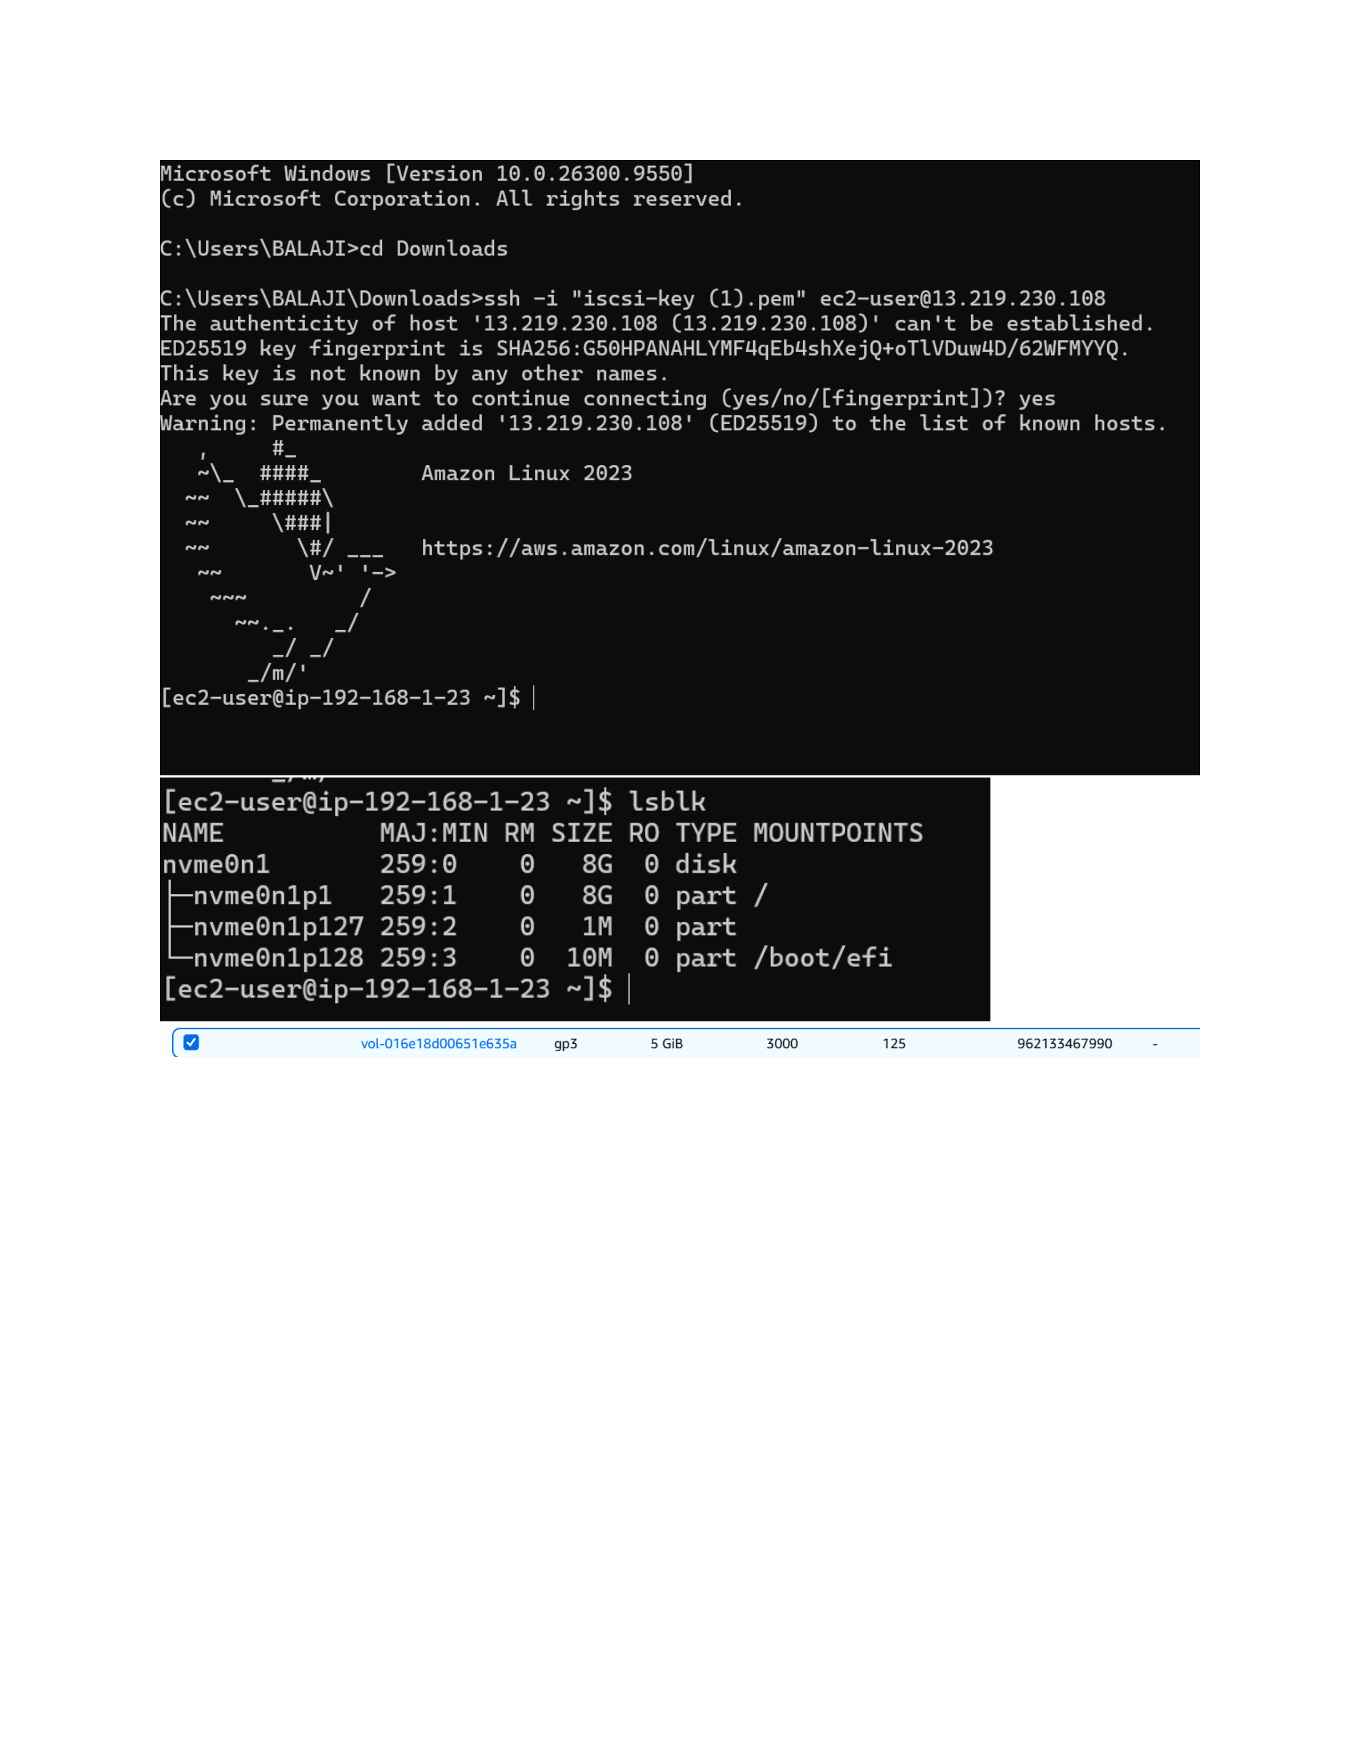
Actual action: From Windows Command Prompt, the SSH command using the iscsi-key PEM file is run against the EC2 public IP and the host authenticity prompt is reached.

Page 4 — Attach the EBS Volume
Topic: Attach the EBS volume to EC2
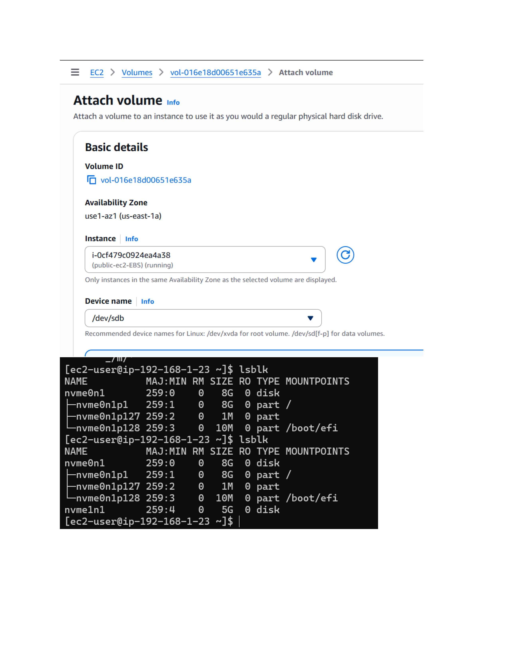
Actual action: The 5 GiB EBS volume is selected for attachment to the running public-ec2-EBS instance in the same Availability Zone.

Page 5 — Inspect the EC2 Disks
Topic: fdisk and block-device inspection
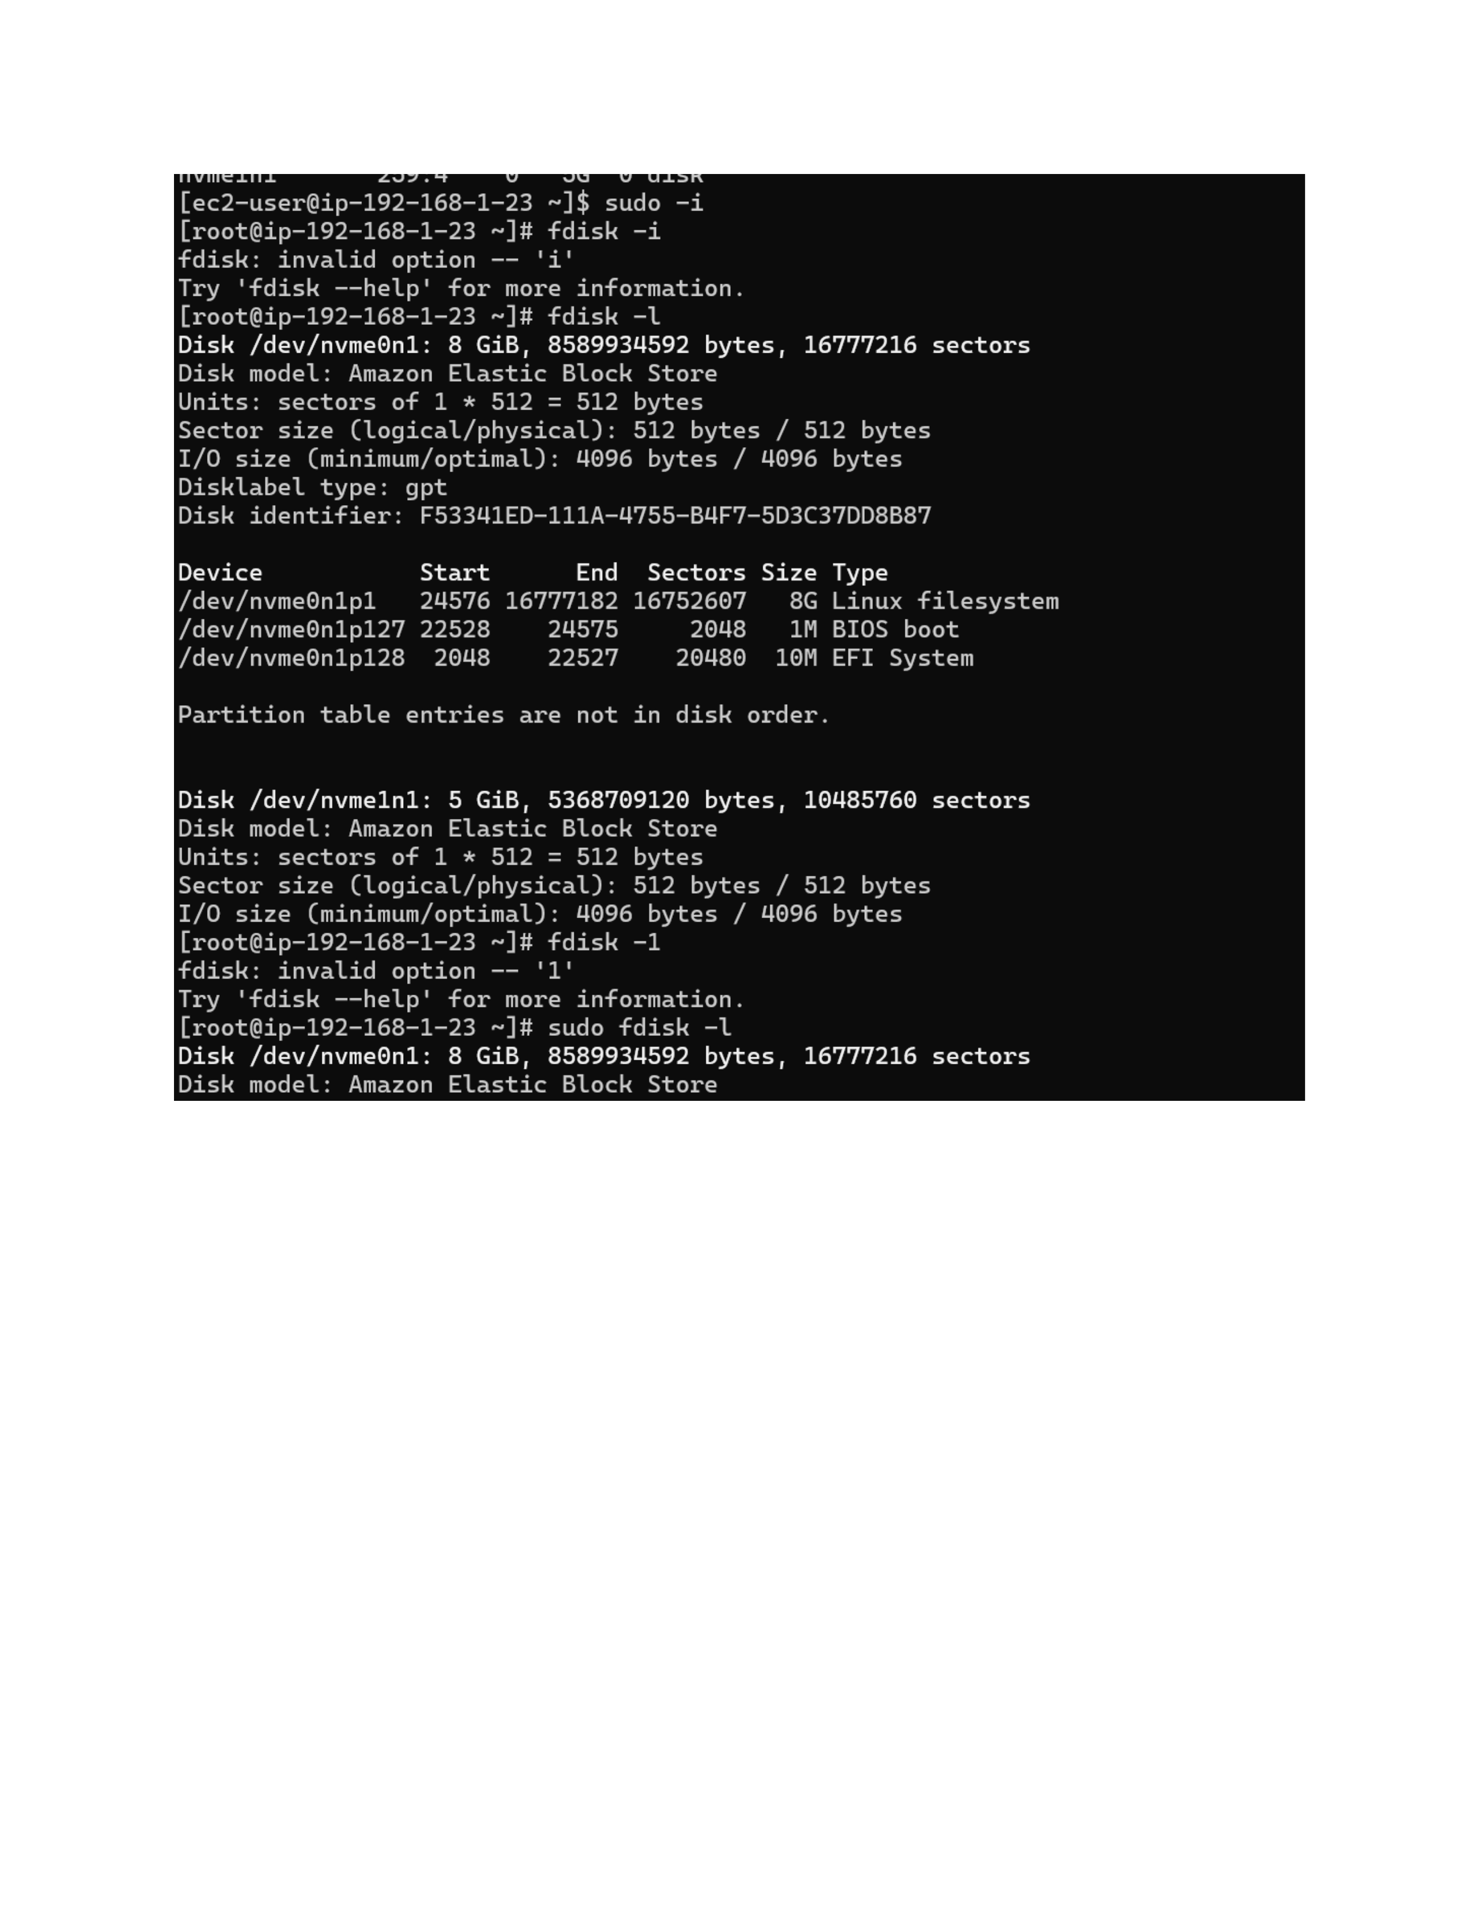
Actual action: The terminal is switched to root and fdisk is used to inspect the available disks; the command output shows the 8 GiB root disk and the additional 5 GiB EBS disk.

Page 6 — Review the Disk Layout
Topic: Partition table and device details
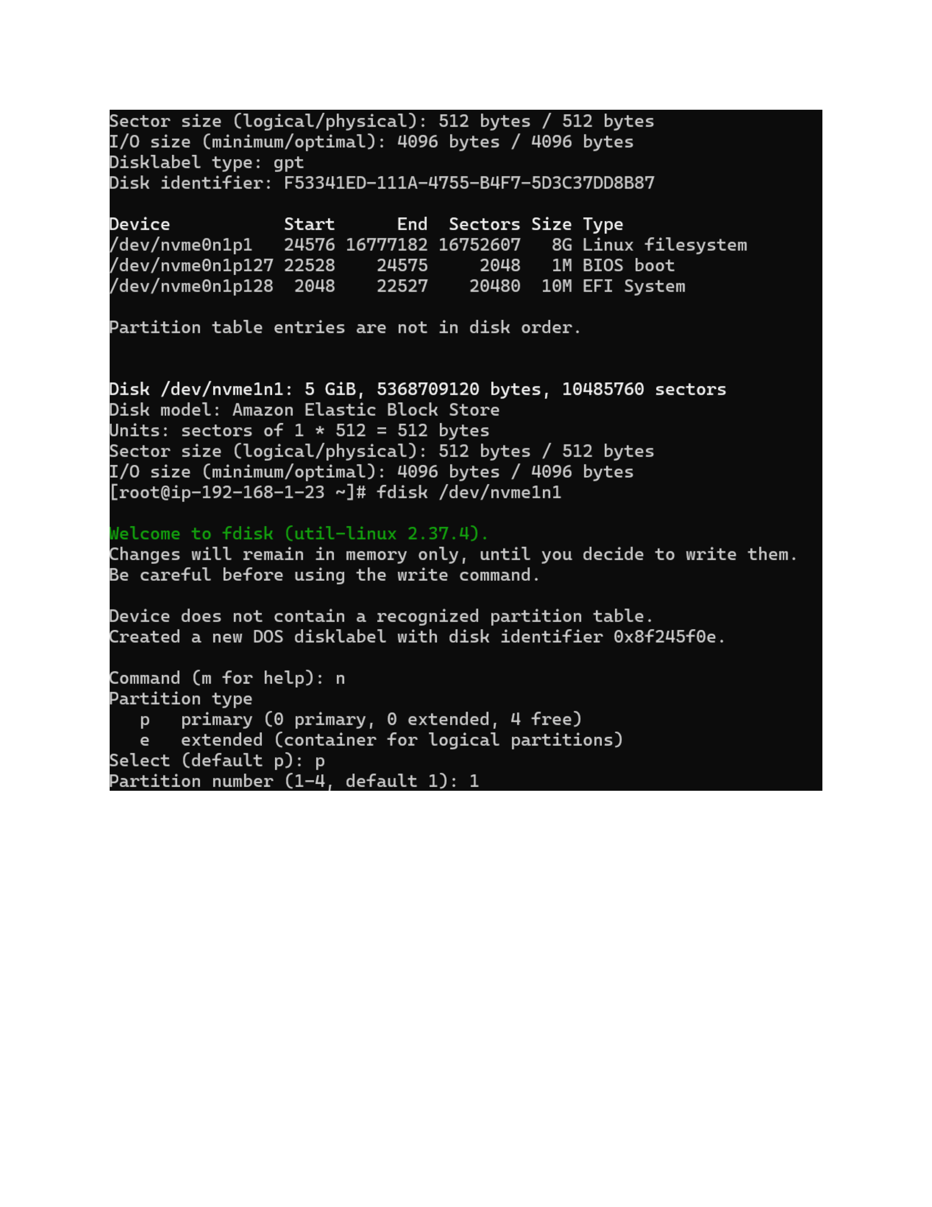
Actual action: The fdisk output is reviewed to identify the existing GPT partition layout and the available 5 GiB disk that will be partitioned.

Page 7 — Create a 5 GiB Partition
Topic: Disk partition creation
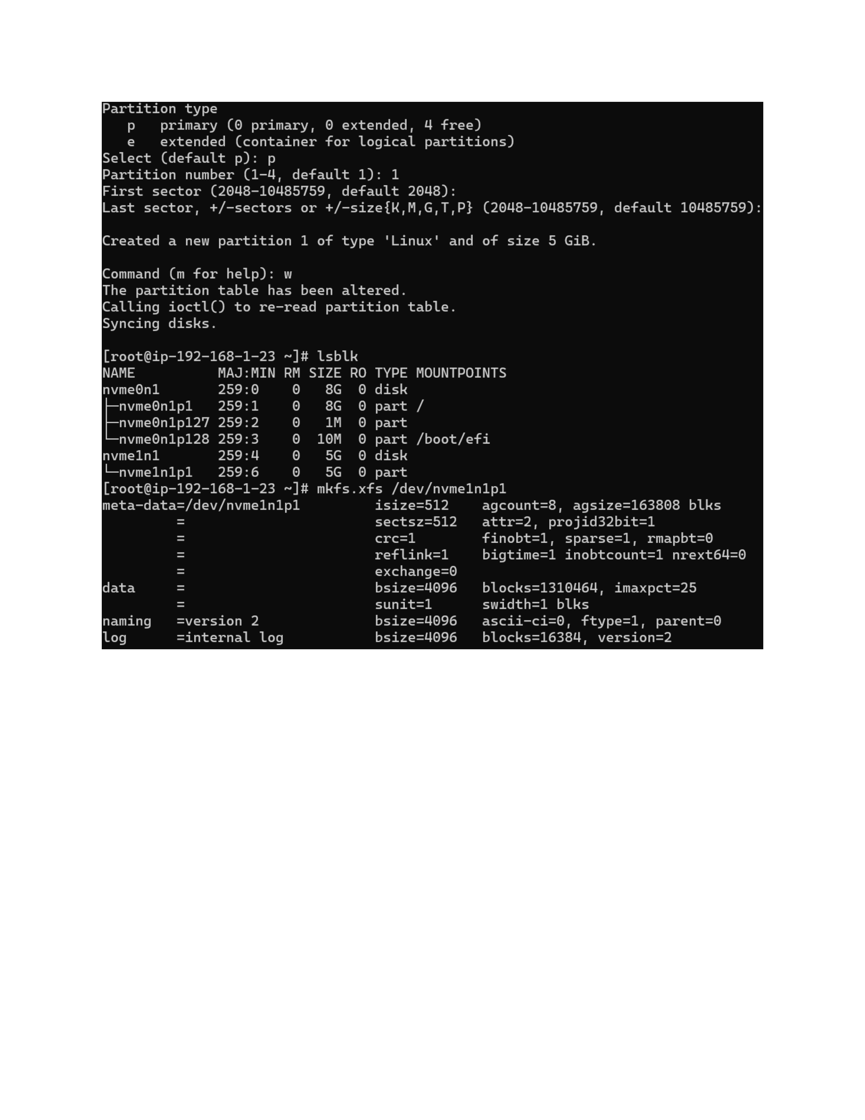
Actual action: fdisk is used to select a primary partition; the default start/end sectors are accepted, creating partition 1 with a size of 5 GiB.

Page 8 — Verify and Prepare the Filesystem
Topic: lsblk, filesystem and mount point
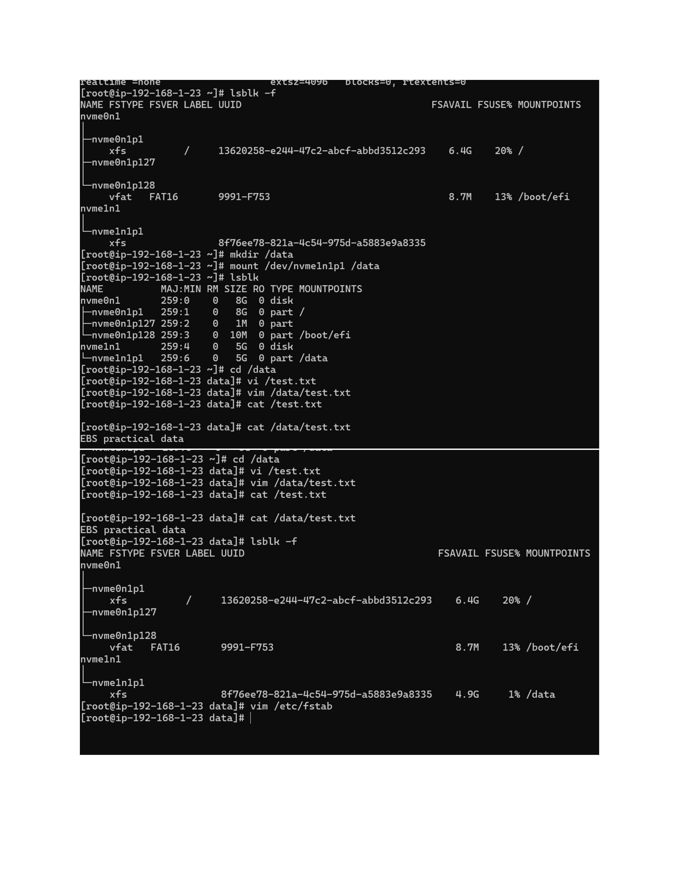
Actual action: lsblk -f is used to inspect filesystem information, and the /data mount directory is created for the additional EBS partition.

Page 9 — Configure Persistent Mounting
Topic: /etc/fstab configuration
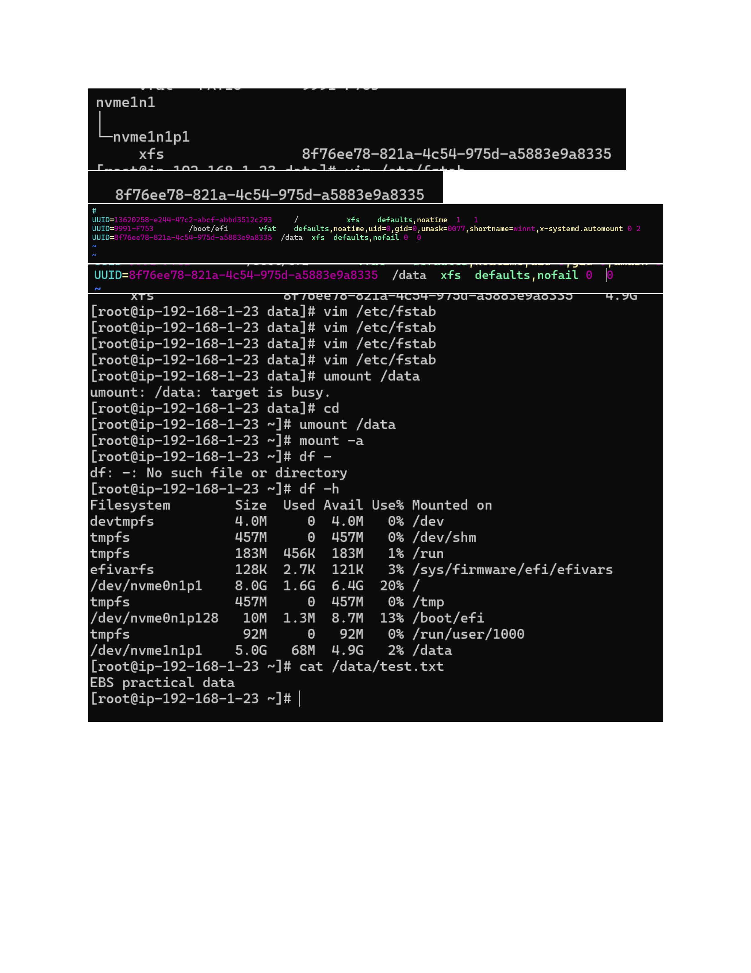
Actual action: The /etc/fstab configuration is edited to define the additional filesystem for /data; an unmount attempt initially reports that /data is busy.

Page 10 — Unmount and Verify the Volume
Topic: Unmounting and storage verification
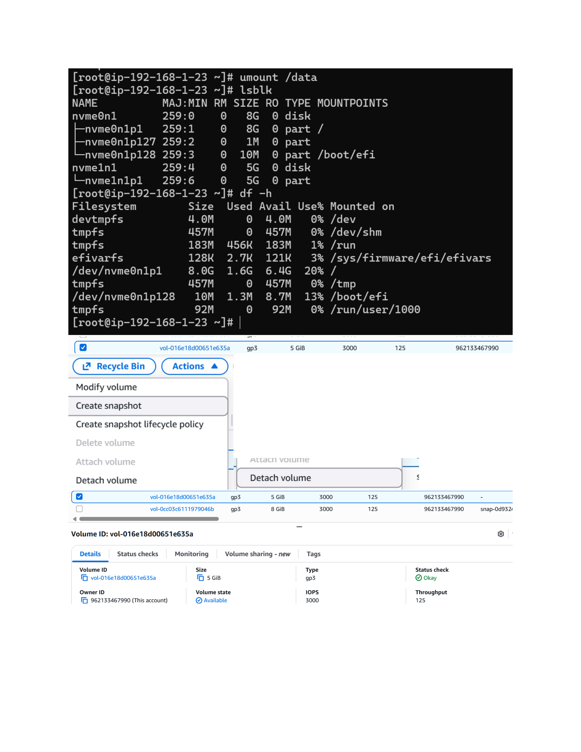
Actual action: /data is successfully unmounted, then lsblk and df -h are used to verify the 5 GiB disk/partition and current mounted filesystems.

Page 11 — Attach the EBS Volume Again
Topic: EBS volume attachment verification
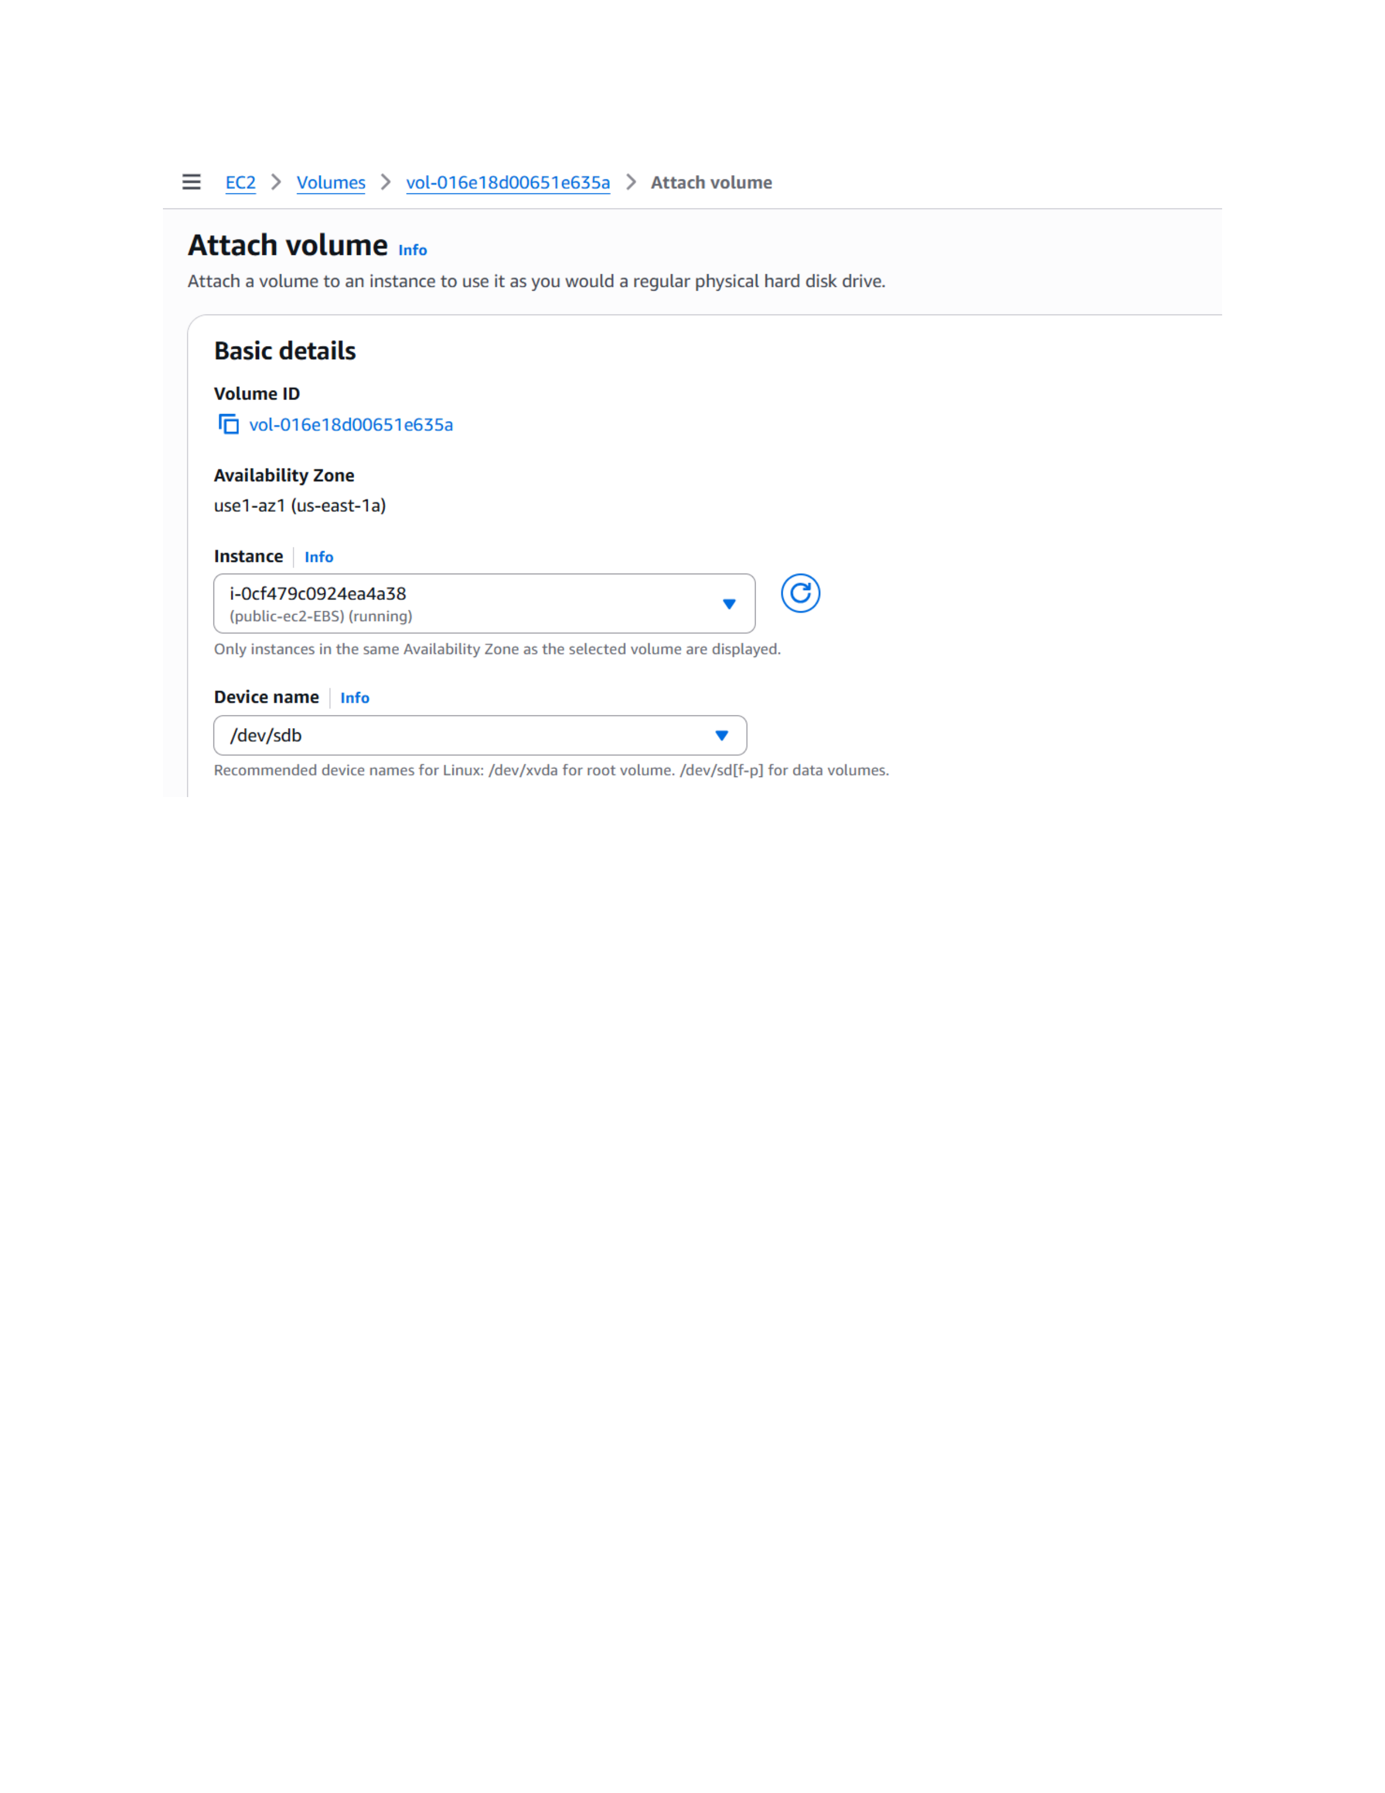
Actual action: The EBS volume attach screen is shown with the 5 GiB volume selected for the running public-ec2-EBS instance in us-east-1a.

Page 12 — Final EBS Volume Verification
Topic: Volume details and health status
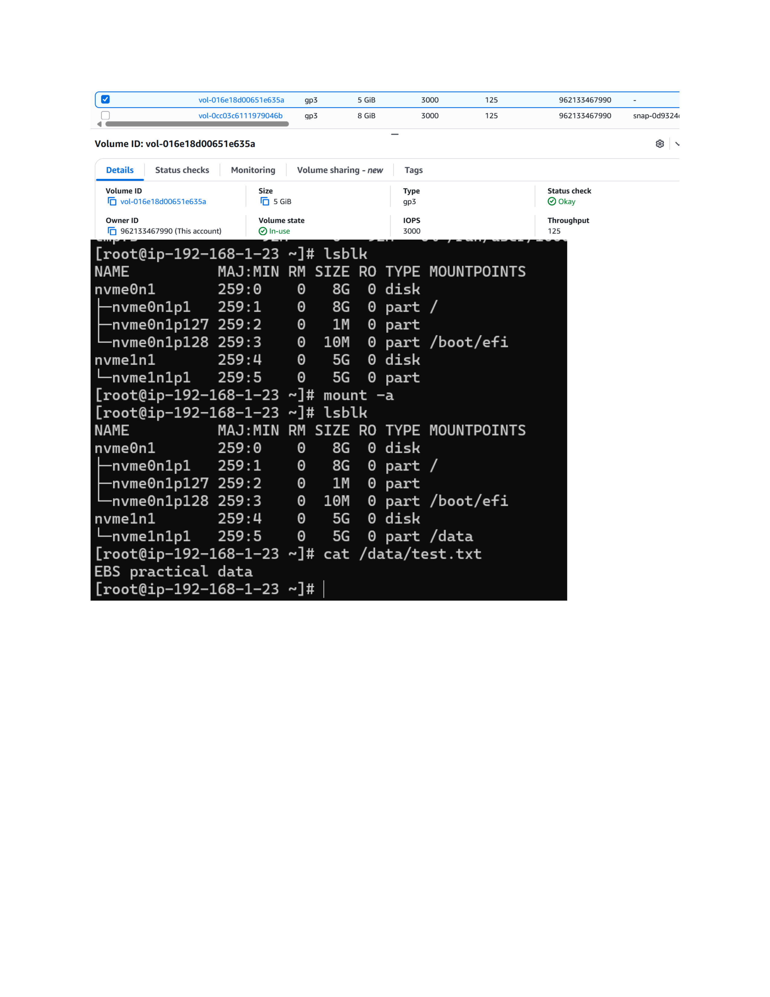
Actual action: The EBS Volumes page shows the 5 GiB gp3 volume, its volume ID, state/details, and status checks for final verification.

